**(1) Read the image using opencv :**

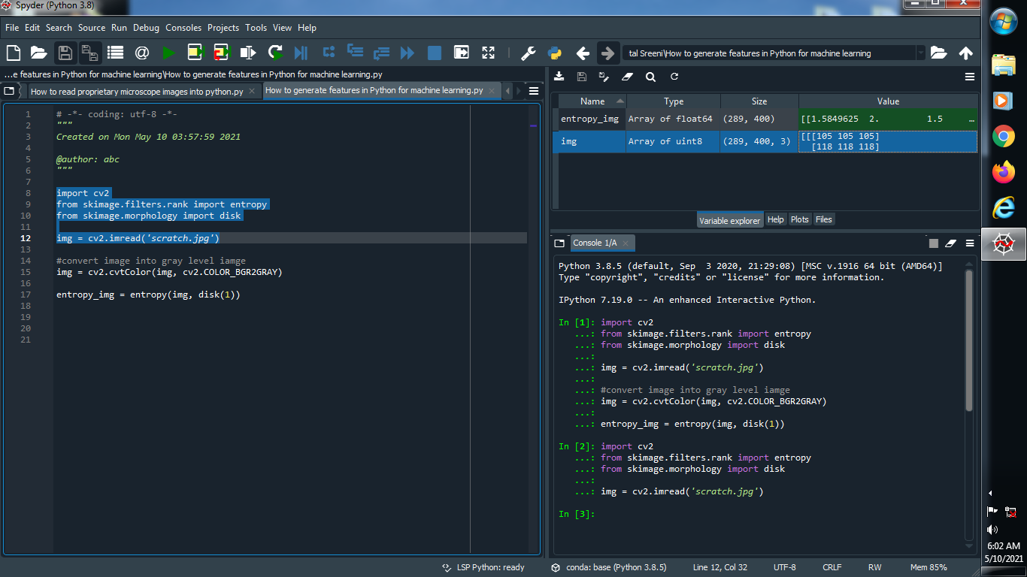

**Output :**



**(2) Convert image into gray level image :**

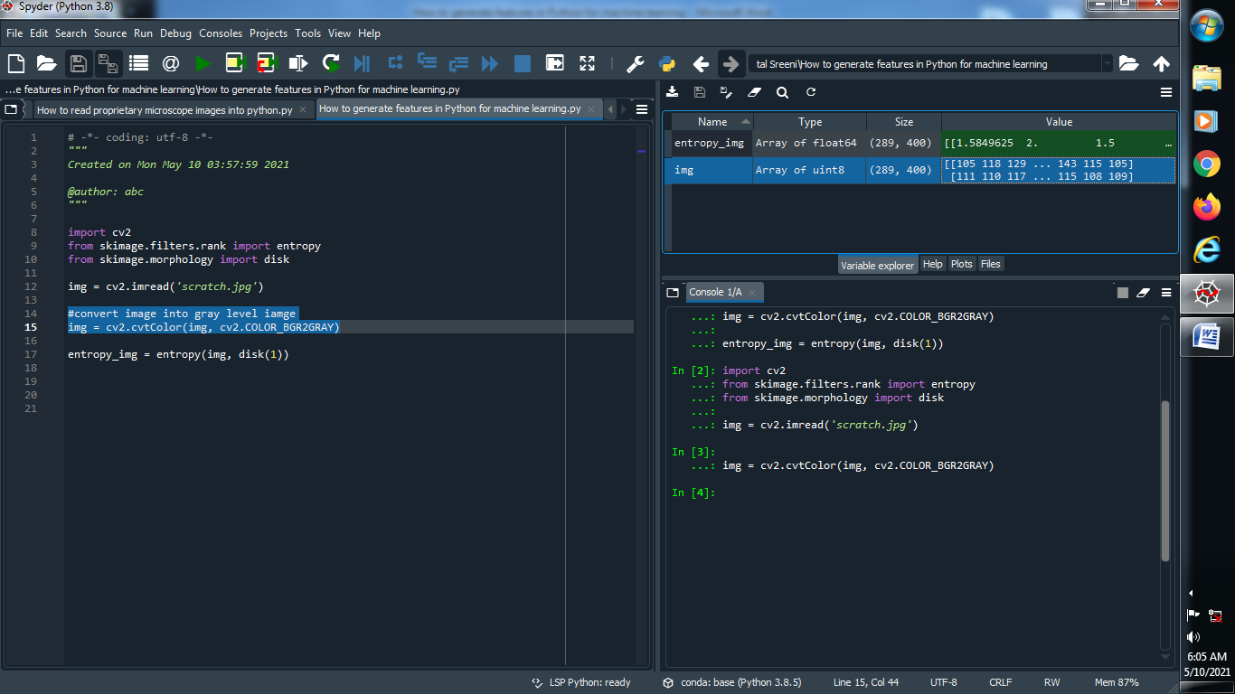

**Output :**



**(3) Apply Entropy filter :**

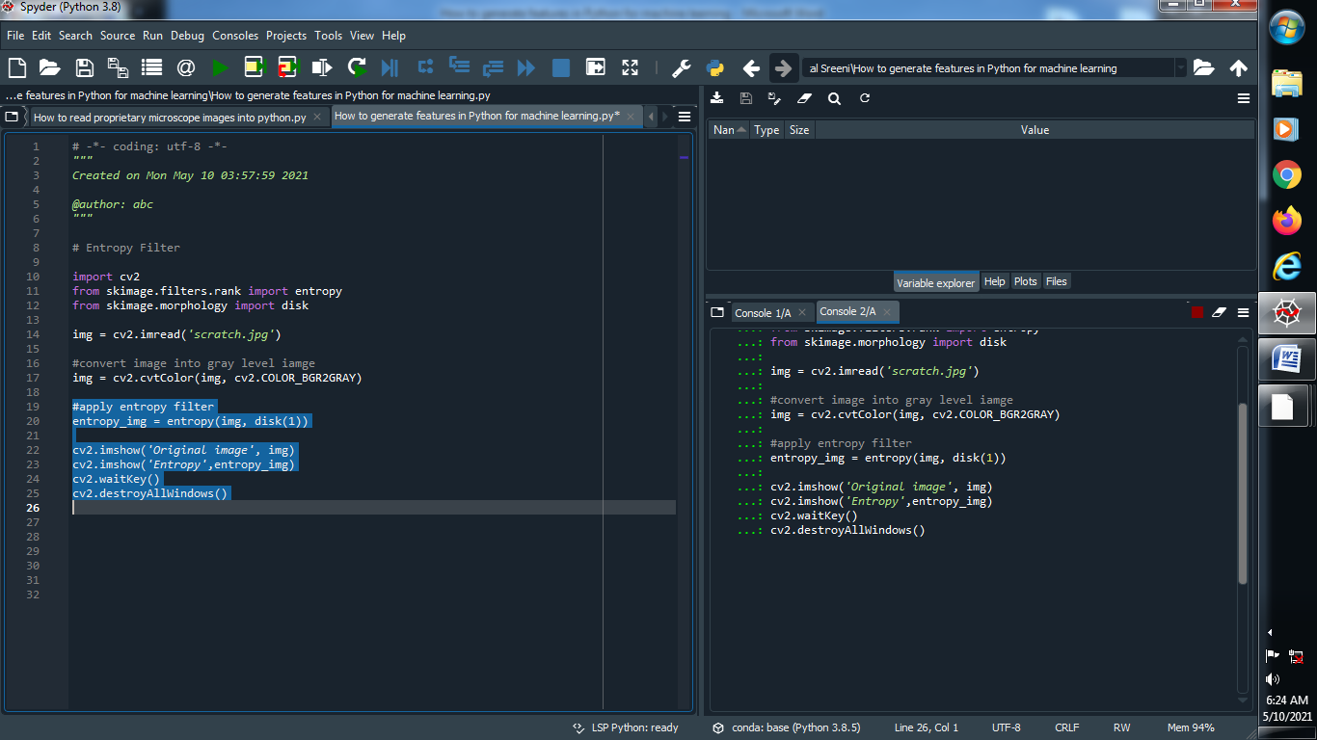

**Output :**

**Original image : Entropy image :**

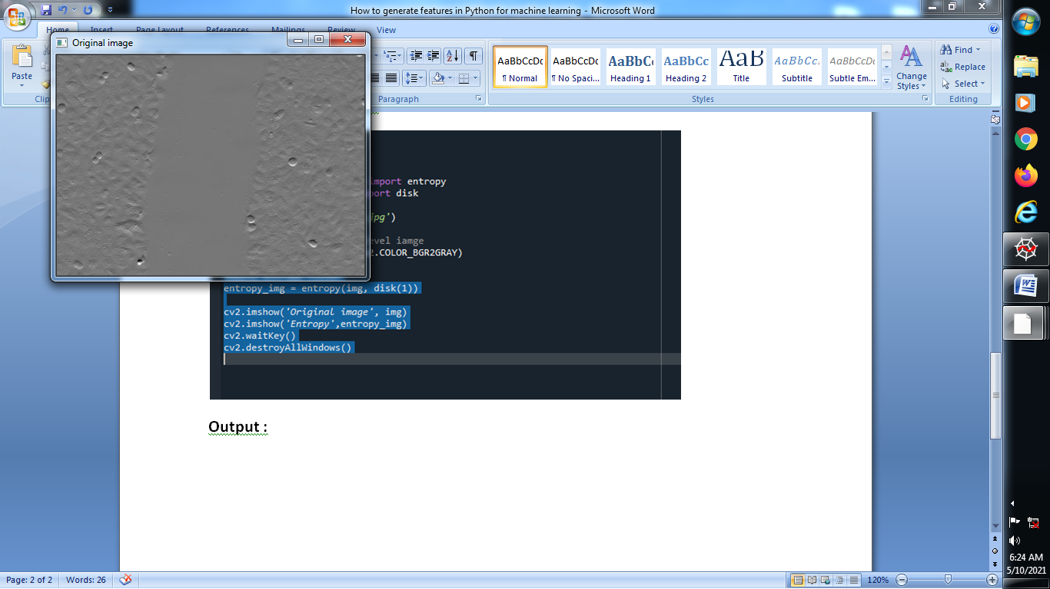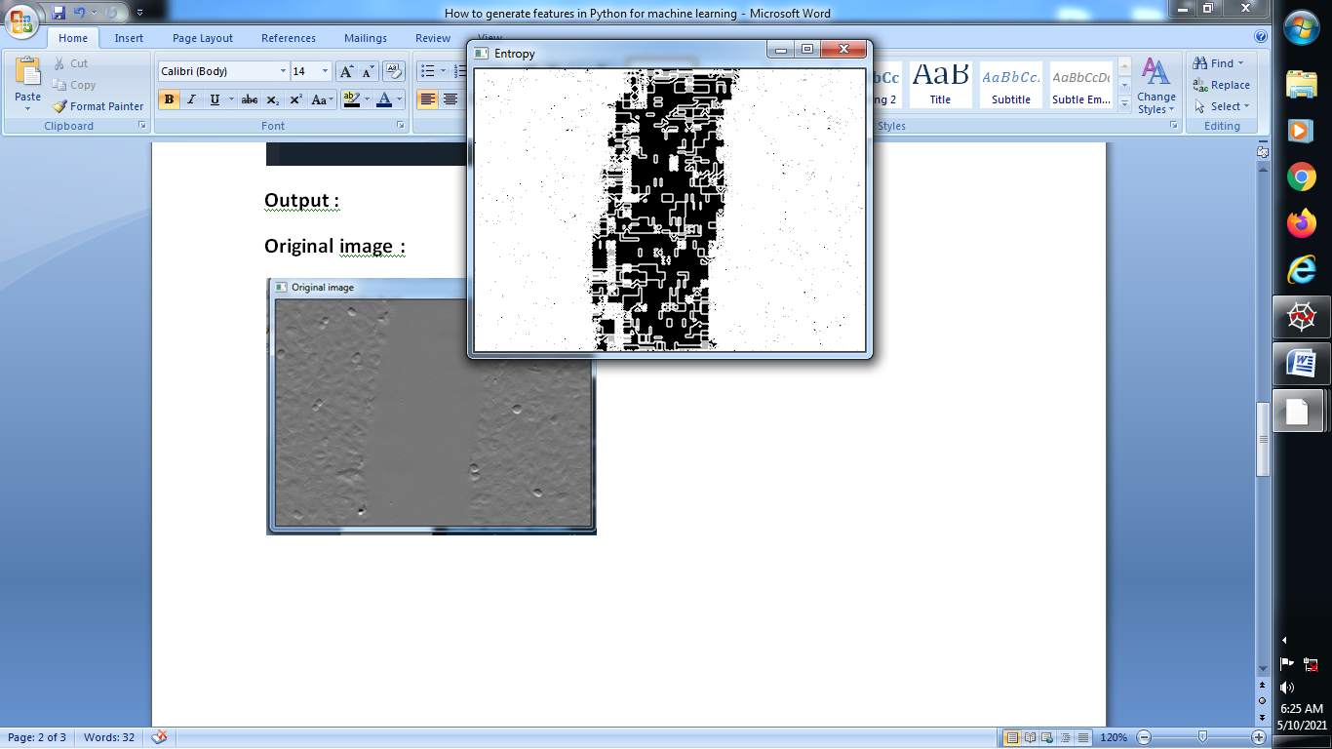

**(4) Another example of entropy example :**

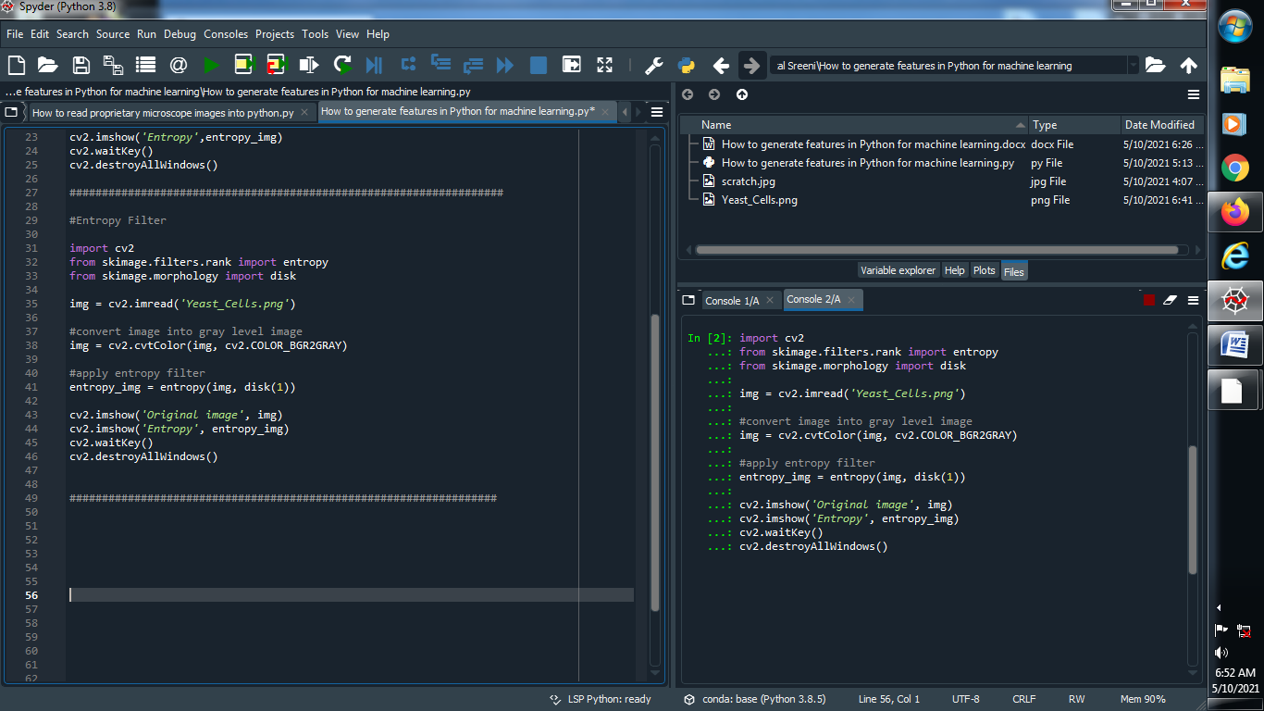

**Output :**

**Original image : Entropy image :**

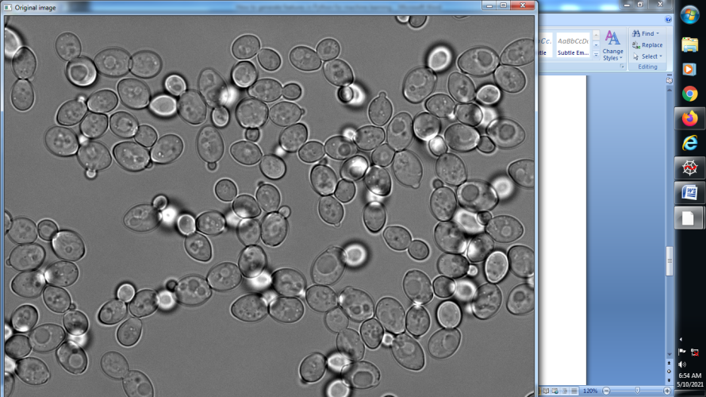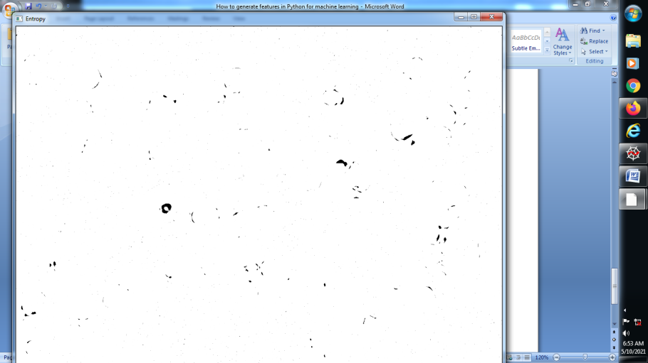

**(5) Apply Gaussian filter :**

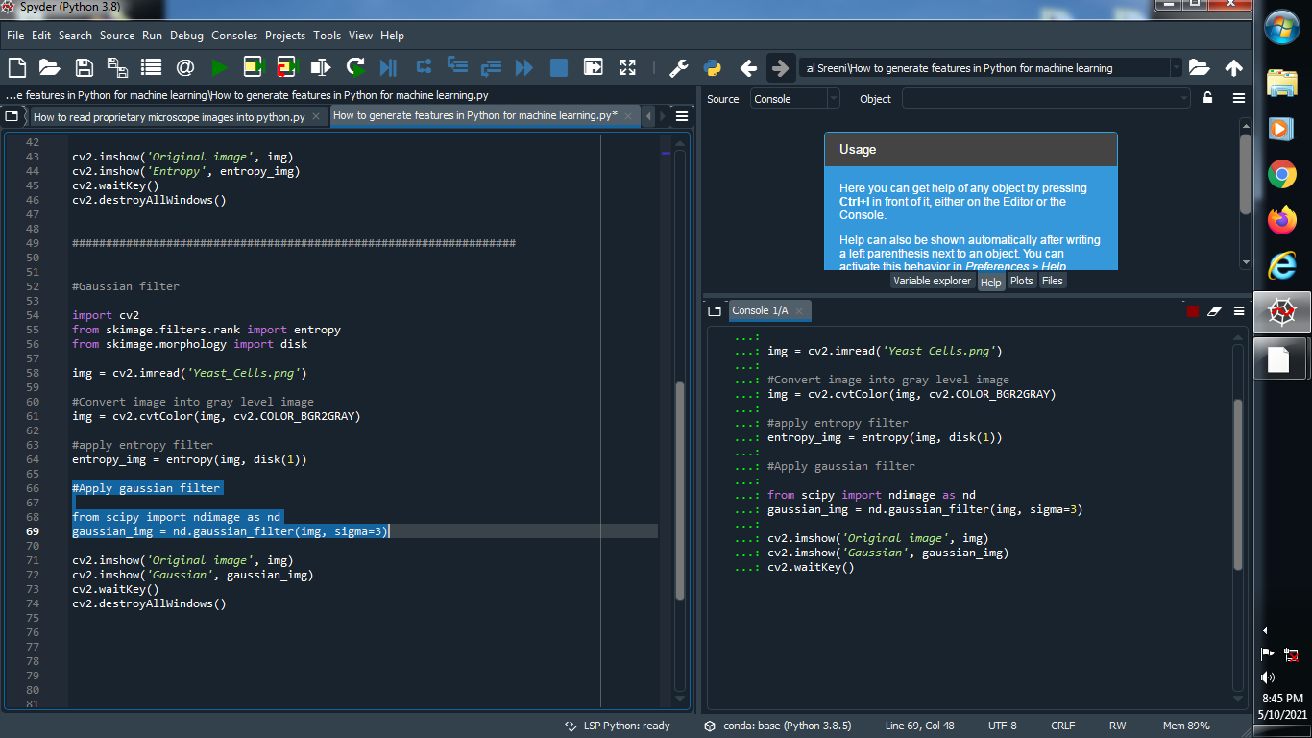

**Output :**

**Original image : Gaussian image :**

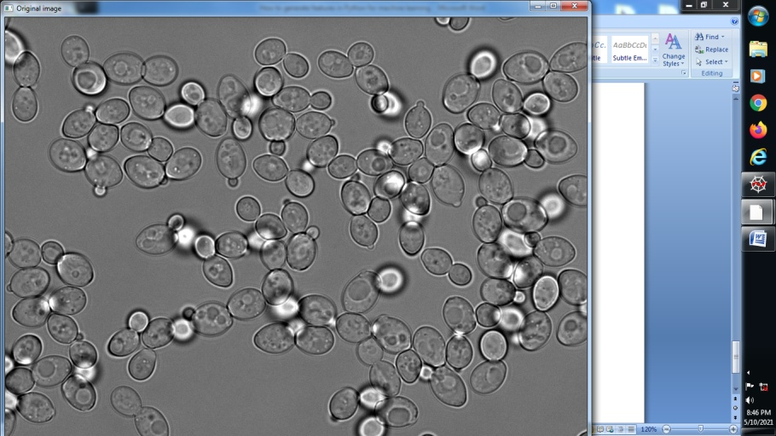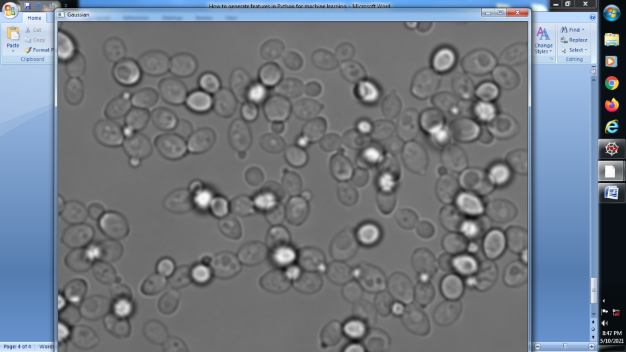

**(6) Apply sobel filter :**

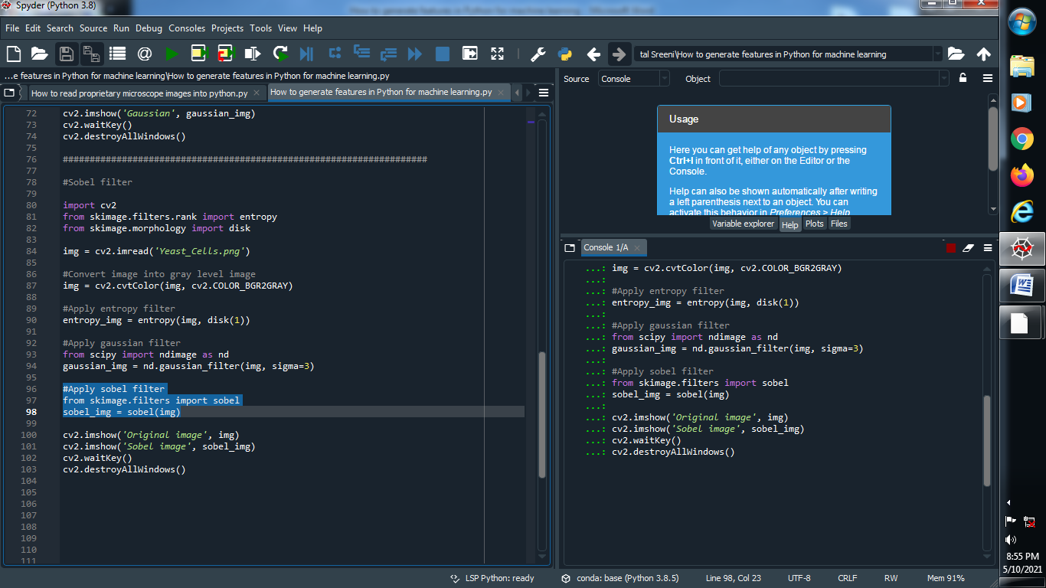

**Output :**

**Original image : Sobel image :**

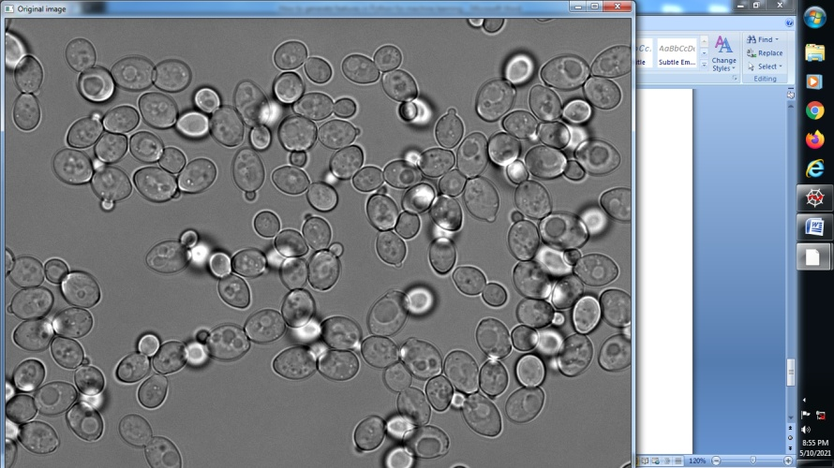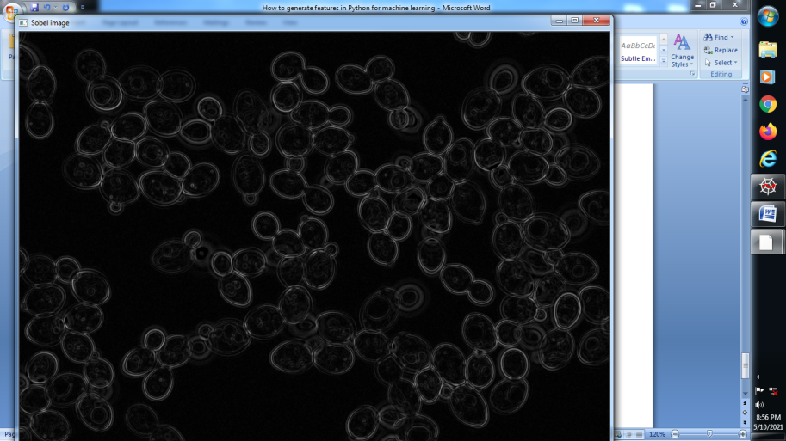

**→ Now Apply that above all information together using dataframe in pandas**

**(1) import library’s and read our image and convert into gray level image :**

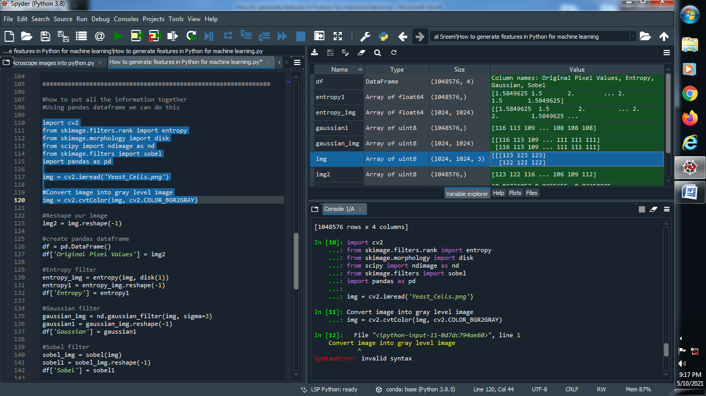

**Output :**



**(2) Reshape our image :**

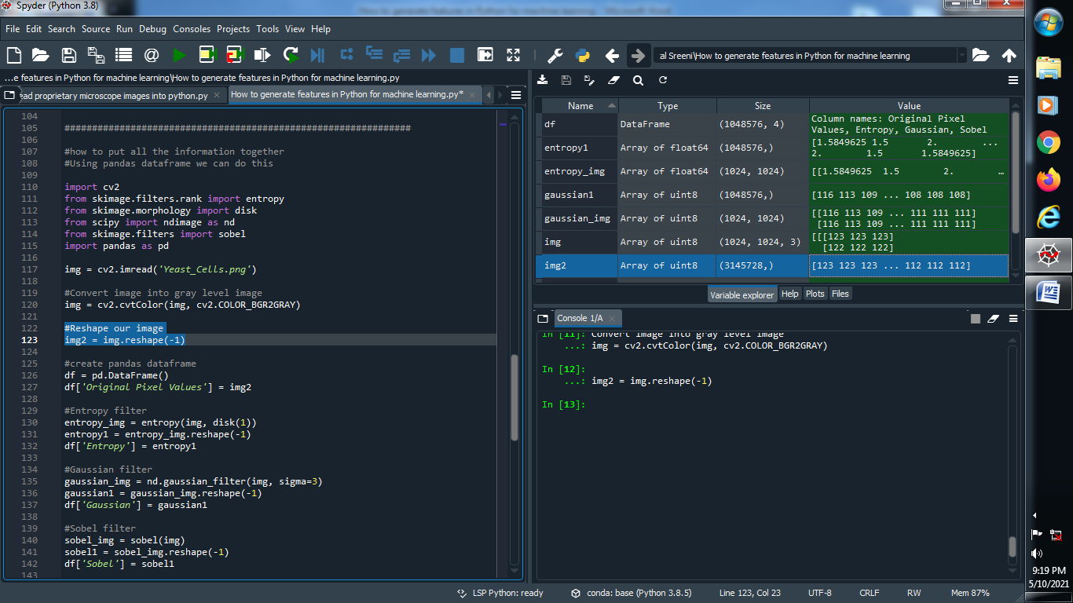

**Output :**



**(3) Create pandas dataframe :**

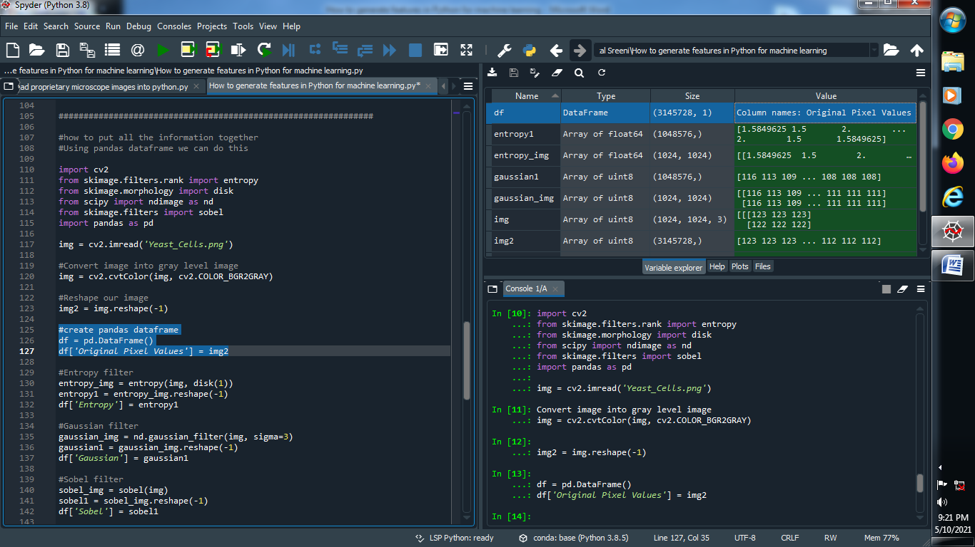

**Output :**



**(4) Apply entropy filter :**

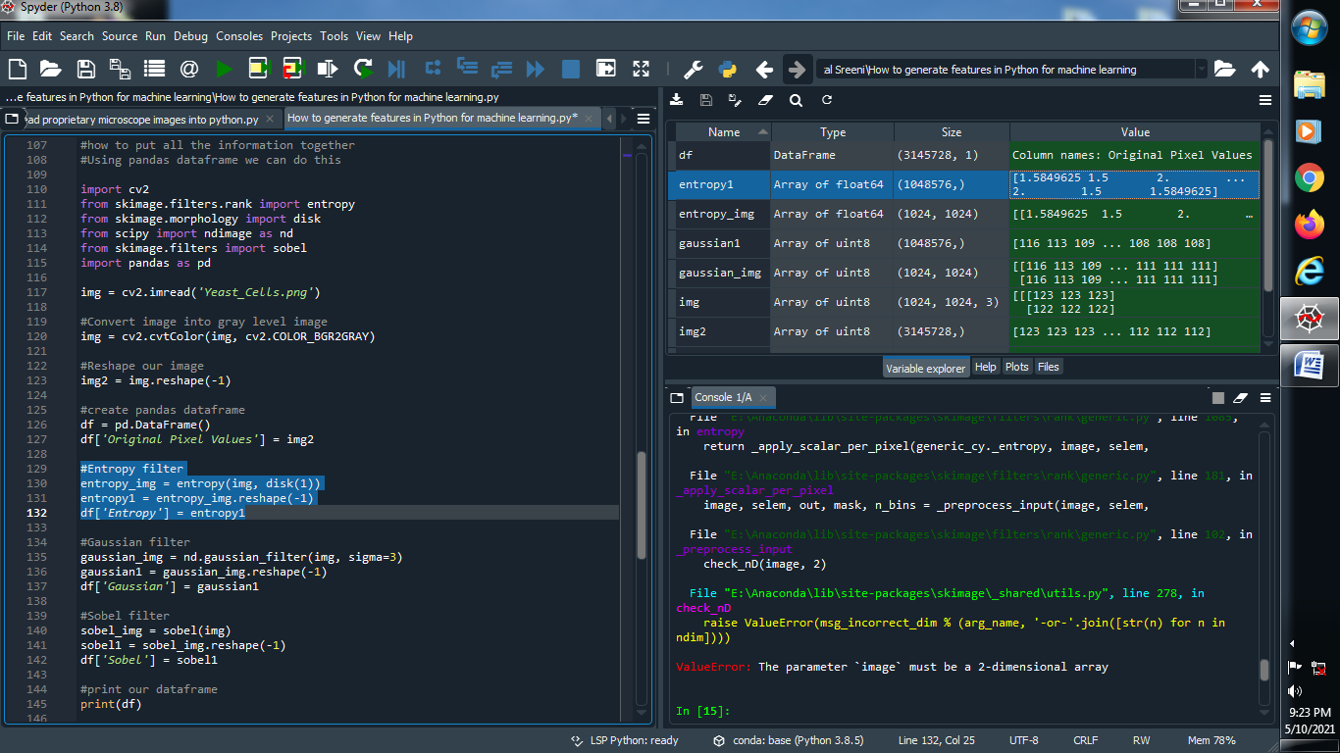

**Output :**



**(5) Apply Gaussian filter :**

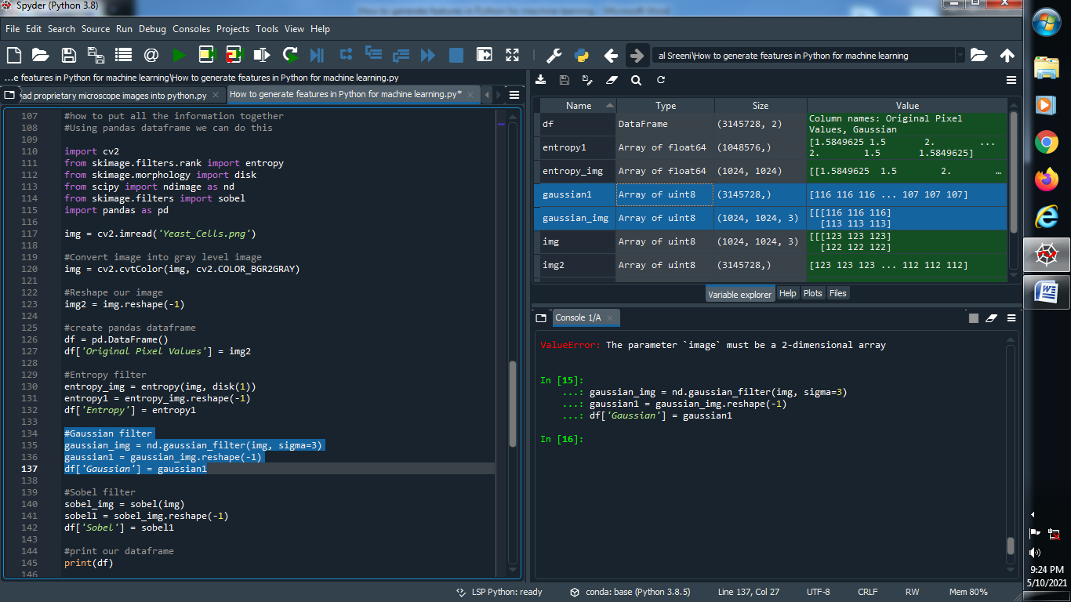

**Output :**



**(6) Apply Sobel filter :**

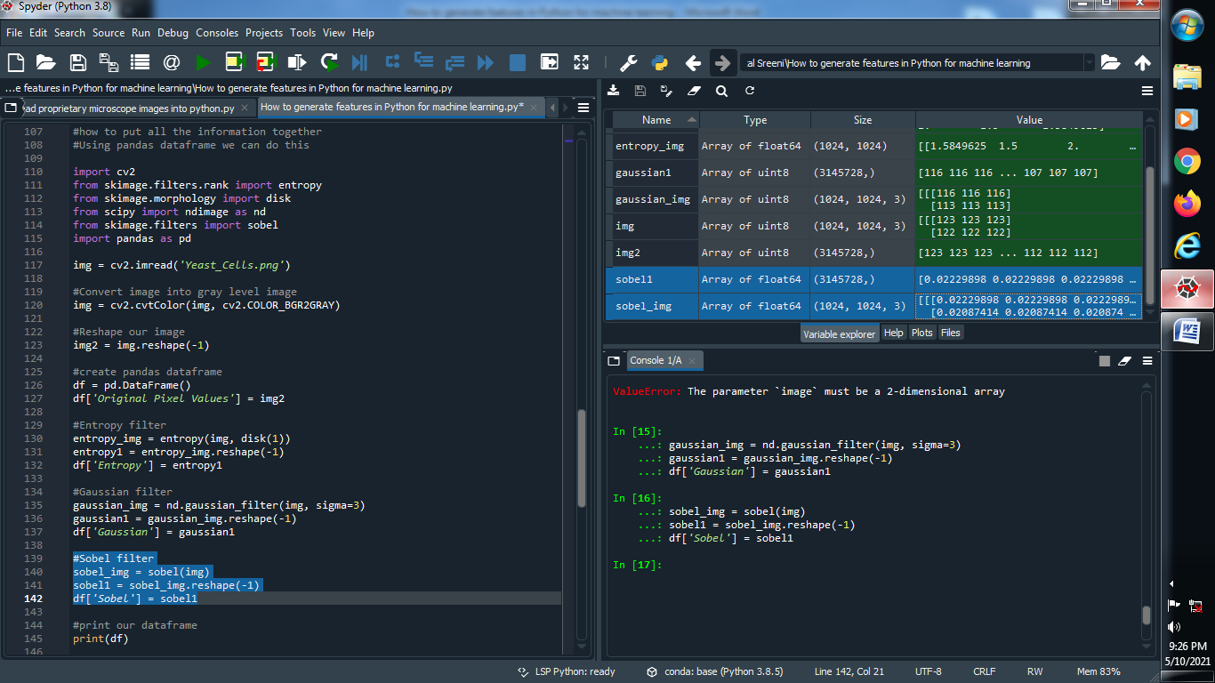

**Output :**



**(7) Print our dataframe :**

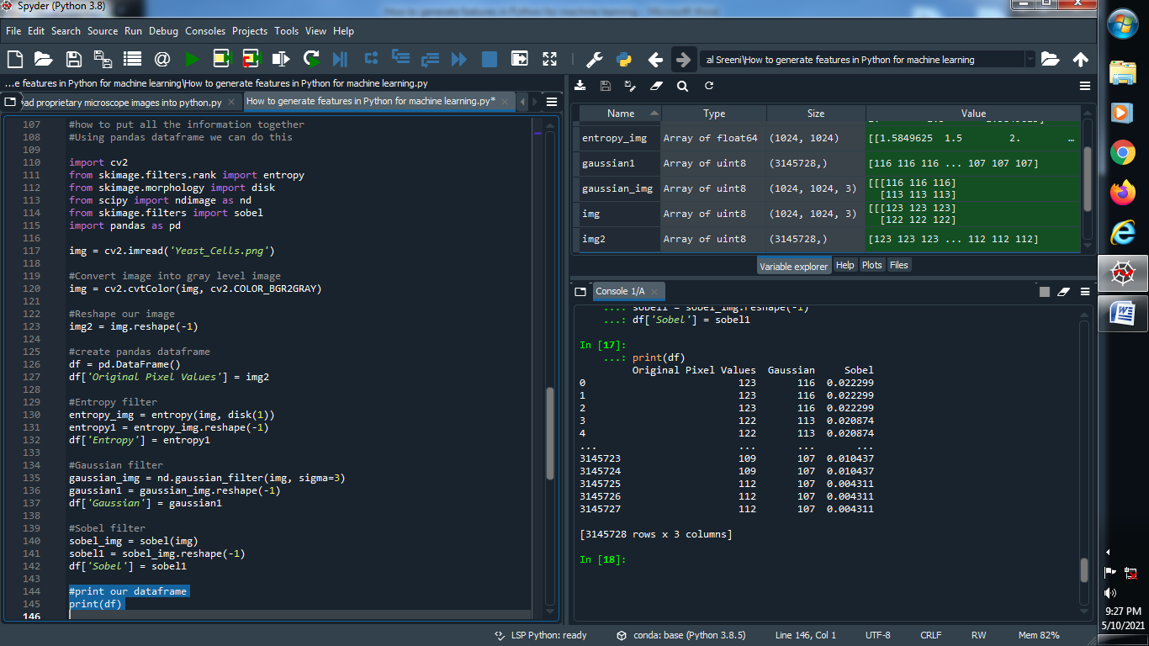

**Output :**

